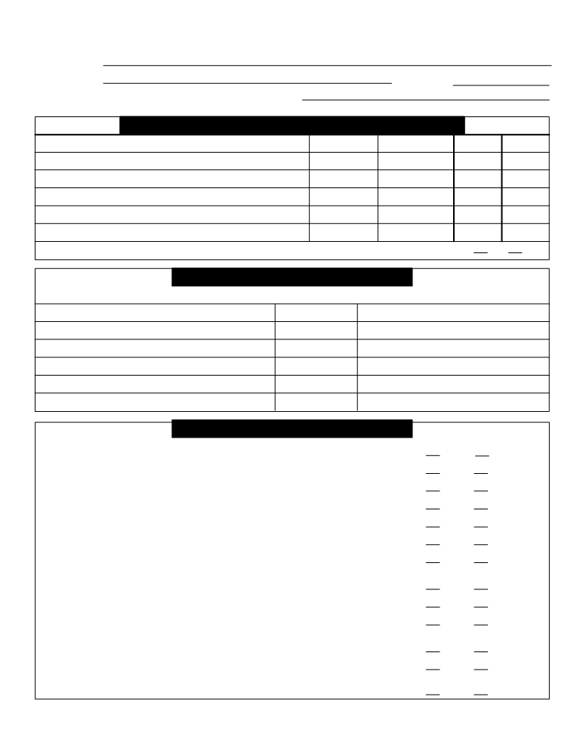

Albert E. Jeffrey Tax Client Tax Checklist Tax Year: 2011
Client Name
Address Day phone
Did you change your name, address, or marital status?

Did You Add or Remove any Dependents This Year?
First and Last Name Date of Birth SSN New Remove

Can you or your spouse be claimed as a dependent on someone else's tax return this year? Yes No

Tax Payments
If you made any IRS estimated tax payments this year please list the following:
Date paid Amount paid
Prior year refund applied:
First quarter payment:
Second quarter payment:
Third quarter payment:
Fourth quarter payment:

Current Year Changes

Did you have any major changes in income this year, or do you expect any next year? Yes No

Did any dependent child under age 18 receive any investment income this year? Yes No

Did you reside in or receive income from another state this year? Yes No

Did you or your spouse sell any assets this year? Yes No
Did you participate in any tax deferred exchanges this year? Yes No

Did you collect any payments on real estate transactions this year? Yes No

Did you buy or sell a personal residence this year? Yes No
If so please attach a copy of your closing papers

Are you or your spouse disabled? Yes No

Are you or your spouse blind? Yes No

Did you have any interests in a partnership, S corporation, estate, or trust this year? Yes No
If so please attach a copy of each form K-1 you received.

Did you receive a Mortgage Credit Certificate for your mortgage interest this year? Yes No
Did you refinance your mortgage this year? Yes No
If so please attach a copy of your closing papers.
Do you want to apply this year's refund to next year's tax liability? Yes No



Client Tax Checklist (page 2)
Income
Income Checklist
Please provide the following documents or information if applicable:

W2 forms for wages salaries and tips

Forms 1099 for interest, dividends, and pension payments
Brokerage statements showing investment transactions
K-1 forms from partnerships, S corporations, estates, and trusts Self-employment income and expense summary
Rental income and expense summary
Forms showing unemployment compensation and social security benefits received 5498 forms for IRAs
Attach a list of any other income from any other source

Child Care Provider Information

Amount paid this year? $ Amount paid this year? $
Name Name
Address Address
City, State, Zip City, State, Zip
SSN or EIN SSN or EIN
Phone Phone

Itemized Deductions

Medical Contributions Miscellaneous
Prescription drugs $ Church $ Union dues $
Health ins. premiums $ United Way $ Tax prep fees $
Medicare premiums $ Heart/Cancer $ Educational expenses $
Dental ins. premiums $ Clothing, furniture, etc. $ Job seeking costs $
Doctors & dentists $ Charitable miles Investment expense $
Medical mileage $ Professional licenses $
Lab and X-ray $ $ Trade and prof. journals $
Glasses, hearing aids $ $ Safe deposit box $
Safety equipment $
Work tools $
Taxes Interest Paid Business telephone $
Uniforms and laundry $
Real estate taxes $ Home mortgage, 1st $ Professional societies $
State sales tax $ Home mortgage, 2nd $ Business mileage
Boat property tax $ Name Alimony payments $
Auto excise tax $ Address Lottery/Gambling $
State income taxes $ City, State, Zip $
$ $
$ $
$ $



